DMDW LAB – 4

AIM: Demonstrate performing association rule mining on data sets

THEORY:

Association rule mining is a fundamental data mining technique that focuses on discovering interesting relationships, associations, and patterns within large datasets. It is commonly used to find connections between items, events, or transactions in various fields, including retail, marketing, and recommendation systems. Following are the characteristics of it:

* Objective: The primary goal of association rule mining is to reveal hidden associations and co-occurrences within datasets. It helps identify patterns that can be valuable for decision-making and business strategies.
* Applications: Association rule mining finds applications in:

1. Market Basket Analysis: Identifying item associations in retail transactions to optimize product placement and promotions.
2. Recommendation Systems: Suggesting related products or content based on user behavior.
3. Cross-Selling: Enhancing sales by offering complementary products.
4. Anomaly Detection: Detecting unusual patterns or behaviors in various domains, such as network security.

* Itemsets: These are sets of items, products, or events that tend to occur together in transactions. Itemsets can be single items (singleton itemsets) or combinations of items (itemset with two or more items).
* Support: It quantifies the frequency of occurrence of an itemset in the dataset. High support indicates that the itemset is frequently observed.
* Confidence: Confidence measures the conditional probability of finding one item in a transaction given the presence of another item. It reflects the strength of the association between items.
* Lift: Lift is a measure of how much more often items occur together compared to what would be expected by chance. Lift values above 1 indicate a positive association.
* Apriori Algorithm: The Apriori algorithm is a classic method for association rule mining. It identifies frequent itemsets and generates association rules based on these frequent itemsets. It is widely used for market basket analysis and recommendation systems.
* Thresholds: Setting appropriate thresholds for support, confidence, and lift is crucial when generating association rules. Thresholds control the quality and quantity of the rules produced.
* Association rule mining is a valuable tool for uncovering actionable insights from large datasets, enabling businesses to make data-driven decisions and improve various aspects of their operations.

Two methods to use:

**Apriori Algorithm:**

* Uses the "Apriori principle" to identify frequent itemsets.
* Involves candidate itemset generation and pruning.
* May be less efficient for large or high-dimensional datasets.
* Requires multiple passes over the dataset to count support.

**FP-Growth (Frequent Pattern Growth):**

* Constructs a "Frequent Pattern Tree" data structure.
* Avoids candidate itemset generation, making it efficient.
* Excels with large and high-dimensional datasets.
* Employs a single-pass approach over the dataset.

OUTPUT:

Steps to do association rule data mining on weka:

Step1: Create a csv file to display the items and its frequency.

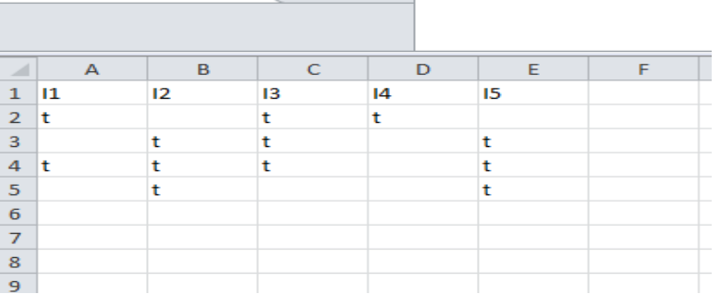

Step2: Open weka explorer and open the file and then select all the item sets.

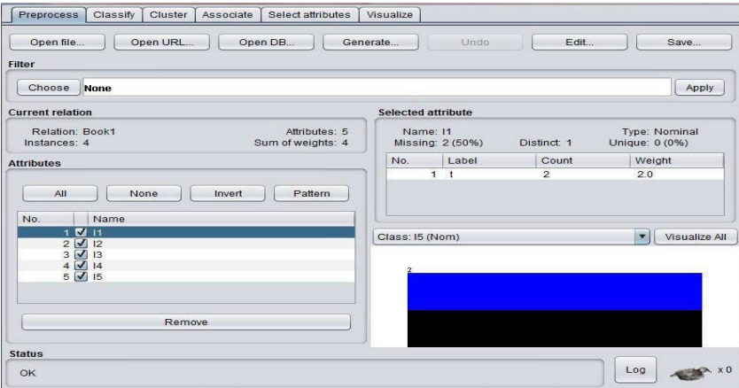

Step3: Now select the association tab and then choose which association rule you want to use.

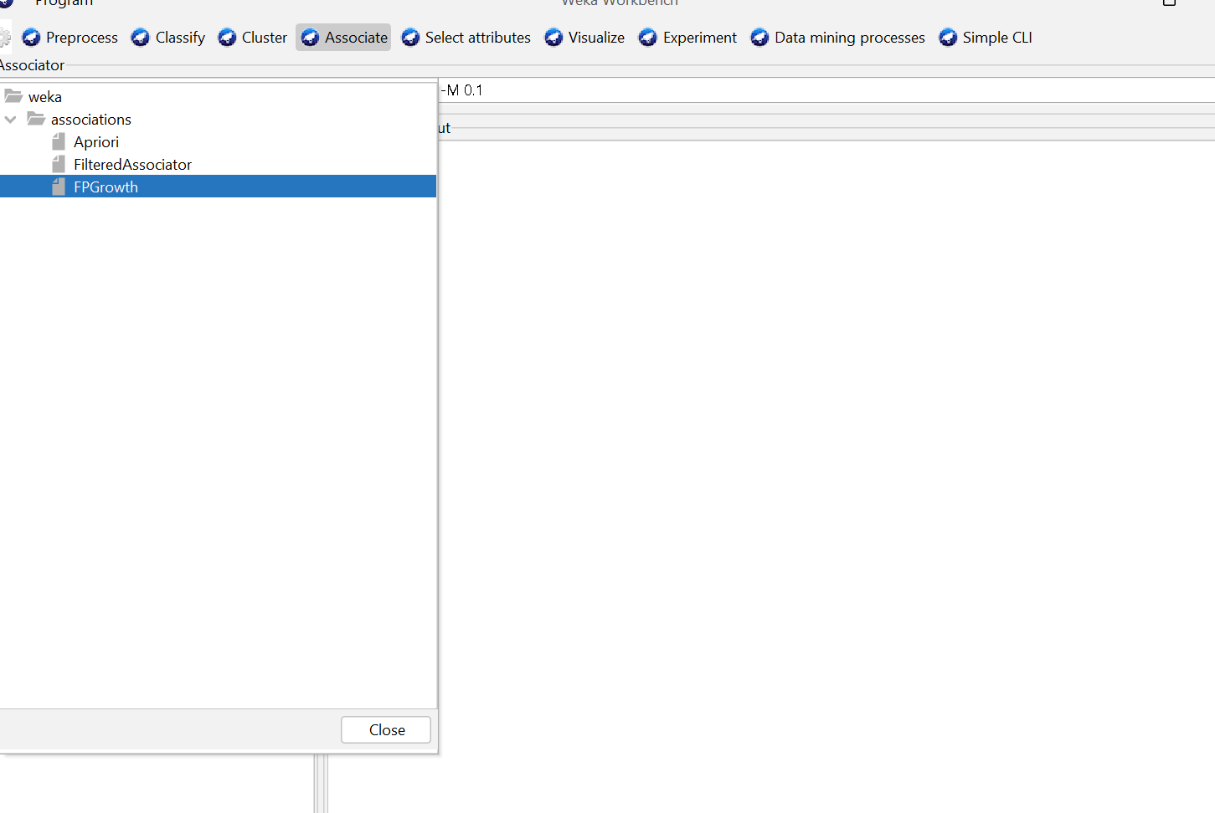

Say we select FP growth, now put in the min support and confidence.

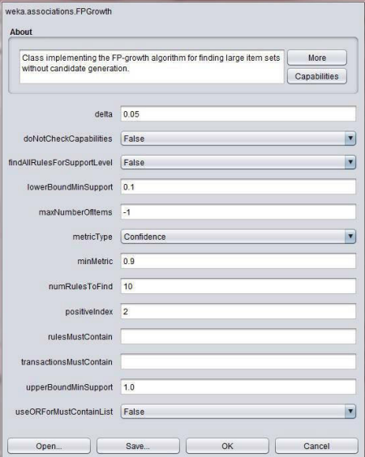

Step4: It will have the following output

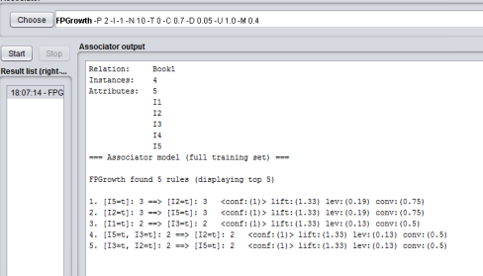

CONCLUSION:

Successfully implemented association rule data mining using WEKA tool on the given dataset.